Technical Explanation of Algorithms:

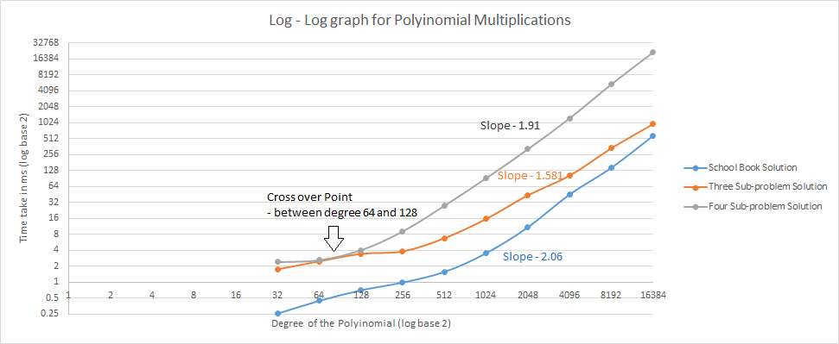

One thing that is common for all the methods is that time taken increases with the increase of number of objects. This not much of a shock since more number of objects = more calculations = more time.

When both the x axis (no of objects) and y axis (time taken) is converted into log scale of base 2 we end up with the above shown graph. We can see that the time taken for divide and conquer is more than that of normal school book method.

In Divide and Conquer method we will have recursive calls and calculations making the running time for the same number of objects.

Even though the slope of the school book algorithm is near 2, the time taken is surprisingly lower than the other two algorithms, **“This is not what I expected but I rechecked the program again and again and run it many times, it all gets me the same values “.** This may be because of the recursive calls over head time.

As expected the three sub problems is taking less time when compared to the four sub problems because this is less number of multiplications and same recursive call over head time.

The anticipated the slope of Three sub problem D&C recursive is close to 1.585 as log23. And also the slopes of other two algorithms are almost equal to 2. We find the cross over point to be somewhere between 64 and 128. The reason for the cross over point is may be because the number of multiplications required may be less than the additions that take place in the other algorithm so we can say that till that point its good and other behaves bad and that changes after the cross over point.